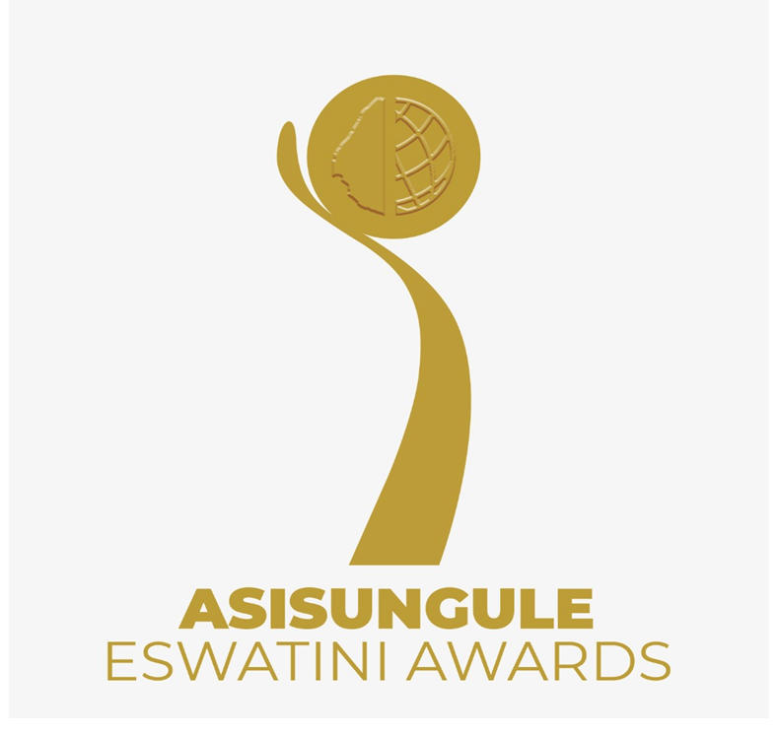
INVENTORS AND INNOVATORS
Application Form

- CONTACT DETAILS
Name | Surname | Name of Business | Contact Number | Age | Gender | Email

- AWARD CATERGORIES

ICT Engineering and Industrial designs

Biotechnology and health Financial Technology Services (Fintech)

Female Game Changer Young Inventors and Innovators
(7 years to 17 years)

Inventors and Innovators living with disabilities Green/Climate/environment solution

Food and Agriculture
Key:
- Female Game changer: A female inventor or innovator of any age, in any category who has emerged as a disrupter.

- Young Inventors and Innovators aged 7 years to 17 years on a class of their own.

- Do you have an?

Invention OR Innovation

(If it’s an Invention go to 3 A) (If it’s an Innovation go to 3 B)

3A. INVENTION, INDUSTRIAL SECTOR AND INTELLECTUAL PROPERTY

- Have you submitted a patent application or have you been granted a patent for your Invention.
- Detailed technical information about the features of the invention

- information about how the invention is made or carried out

- Information showing that the invention is industrially (technologically, scientifically, mechanically, technically) applicable or usable which means it can be used in any kind of industry

- Information showing that the invention is protected through patent law or at least filed for protection.

(Please attach evidence of the Invention Picture, Access Link, Video)

3B. INNOVATION, PROTOTYPE OR PROOF OF CONCEPT

- Describe your Innovation in one of the following ways and provide as much detail as possible.

- Innovation is protected through patent law or at least filed for protection.
OR
A new or novel technology or technique or industrial design.
OR
Technical information about the features of the innovation.
OR
How the innovation is made or carried out?
OR
Industrially applicable (technologically, scientifically, mechanically, technically) or usable which means it can be used in any kind of industry
- Creativity of Concept
- How Much sales income have you made in the past year?

Please attach testimonials of at least 3 users with phone and email contracts.
AND
Please attach evidence of the Invention Picture, Access Link, Video.

- UNDERSTANDING OF OBLIGATIONS APPLICANTS

I/we certify that the information contained in this document is accurate and complete to the best of my knowledge. I/we understand that furnishing inaccurate or misleading information can result in denial of consideration for admission or dismissal from the Asisungule Eswatini Awards. I am / we are willing to disclose intellectual property rights to RSTP for assessment of progress and compliance.

Signature: ………………………………………………………

Date: ………………………………………………………………

Submitted at …………………………………on the ………of …………………20……

By: …………………………………………………………………………

Notes
- Invention
According to World Intellectual Property Organization, is a product or a process that provides, in general, a new way of doing something, or offers a new technical solution to a problem
- Innovation is: - Essentially about doing “something” different in one or more of four ways:
- Pioneering a new product or technique or significantly improving the quality of an existing one;
- Devising a new and viable business model;
- Creating a better or cheaper version of an existing product to satisfy an unserved market; and
- Devising a method that takes an existing product to new sets of customers.
- Generating revenue from customers who use that “something” and turning the customers into repeat customers.

- Intellectual Property
According to the World Intellectual Property Organization, intellectual property can one of the following:
- A patent protects inventive ideas or processes i.e. things that are new, useful and nonobvious, for example, designs, processes and newly engineered plant species or strains
- A trademark protects words, phrases, symbols, sounds, smells and color
- A copyright protects the manner in which ideas are expressed and this covers literary works (such as novels, poems and plays), films, music, artistic works (e.g., drawings, paintings, photographs and sculptures), and architectural design even programming code for software.
- A trade secret is any confidential business information (technical or commercial information) which provides an enterprise a competitive edge and is unknown to others.

