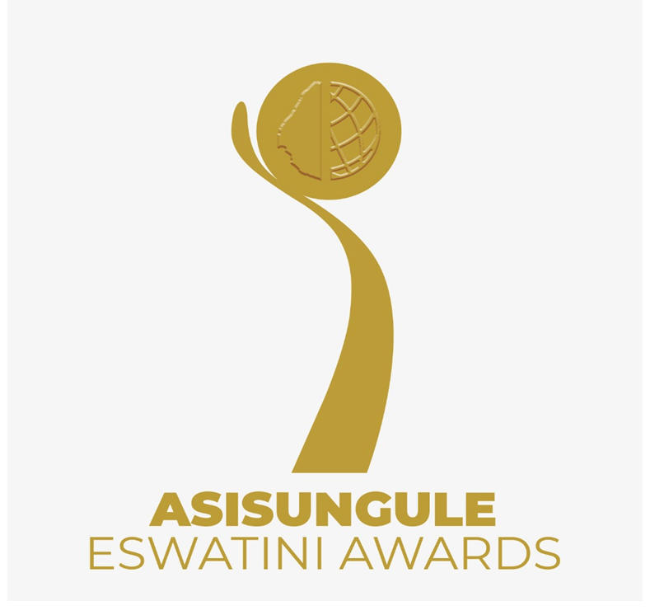
CALL FOR APPLICATIONS
Opening call: 16th June 2021
Deadline of submission: 15 December 2021

- Scope
A total number of 150 Inventors and innovators will be evaluated and selected. A total of 27 applicants will be winners from the 9 sectors.
The aim is to;
- To enable the public to obtain new technological knowledge and inspire other inventors to innovate further while avoiding “reinventing the wheel”.
- To increase market exposure, networks and opportunities for nominees and winners.
- To reward inventors and innovators, especially the youth and women, for their time, effort, money and creativity.
- To increase the number and value of locally generated inventions and innovations in the local and exports markets.

- Who can apply?
- An individual or team aged 7 years and above or a start-up ( incorporated or not) that is either at formation, market validation or scale-up phase
- The applicant must either have an innovation or an invention in the following sectors:
- Information and communication technology
- Engineering and Industrial designs
- Fintech
- Bio-technology and health
- Green-Climate Environment
- Food and Agriculture
- Young inventors and innovators award
- Inventors and Innovators living with disabilities
- Female Game Changer
Key
- Female Game changer: A female inventor or innovator of any age, in any category who has emerged as a disrupter.

- Young Inventors and Innovators aged 7 years to 17 years on a class of their own.
- Prizes
- Fintech Category
1st Prize – E15 000.00
2nd Prize – E10 000.00
3rd Prize – E5 000.00

- Other categories
1st Prize - E5 000.00
2nd Prize - E3 000.00
3rd Prize – Gift Hamper

- Intellectual Property Protection: Inclusive Patent Search for all applicants (Inventors) and IP registration for the top 3 winners to be determined by the kind of patent needed.

Selection Criteria
Criteria
- The selection criteria will focus on a product or business model that is generating sales income or is gaining users/customers, combined any of the following:
- Inventions
An Invention is a product or a process that provides in general, a new way of doing something, or offers a new technical solution to a problem (WIPO).
- Invention is protected through patent law or at least filed for protection
- A new or novel technology or technique or industrial design
- Technical information about the features of the invention
- How the invention is made or carried out?
- Industrially applicable (technologically, scientifically, mechanically, technically) or usable which means it can be used in any kind of industry

- Innovations
A new or significantly improved product (goods or service) or process (Oslo manual). A process of bringing an invention to the users, to the market place, to industrial application (WIPO).

- One or a combination of the following:
- New product or a significant improvement of an existing one that is generating sales income or is gaining users/customers; OR
- A new business model or improvement of an existing one that is generating sales income
- A cheaper version of an existing product that is generating sales income or is gaining users/customers
- Production for or service delivery to a new set of customers and generation of sales income

- Description of innovation and supporting information.

- How the applicants be selected?
First Phase
The first phase will take place at RSTP where the business incubation team will select the top 5 per category (9 categories).
Second Phase
The second phase will be 60 seconds pitching videos which will be opened for ONLY the top 5 participants per category selected in phase 1.
Third Phase
In this phase three winners per category will be chosen by the selection committee.
- Application process
Download application form at www.itbi.org.sz/asisunguleeswatini/ and email the complete application form to incubation@itbi.org.sz before or on the 15th November 2021.

- Schedule – Applicants and Public
Process | Outputs | Start-date | Duration | End-date
Application period | Complete applications received | 16-Jun |  | 15-Dec
Phase1: Evaluation and Selection
Selection & Screening | Selection of top 5 per category | 16 Dec | 5 days | 21 Dec
Notify eligible applicants | 35 Inventors and Innovators | 22 Dec | 1 day | 22 Dec
Phase2: 60 seconds pitching videos | Open only for top 5 Nominees | 05 Jan | 2 days | 7 Jan
Phase 3 : Selection | Top 3 nominees | 10 Jan | 5 days | 14-Jan
Notify eligible top 3 applicants | Top 3 nominees | 17-Jan | 1 day | 17-Jan
Exhibition | Top 3 nominees | 04-Feb | 1 day | 04-Feb

