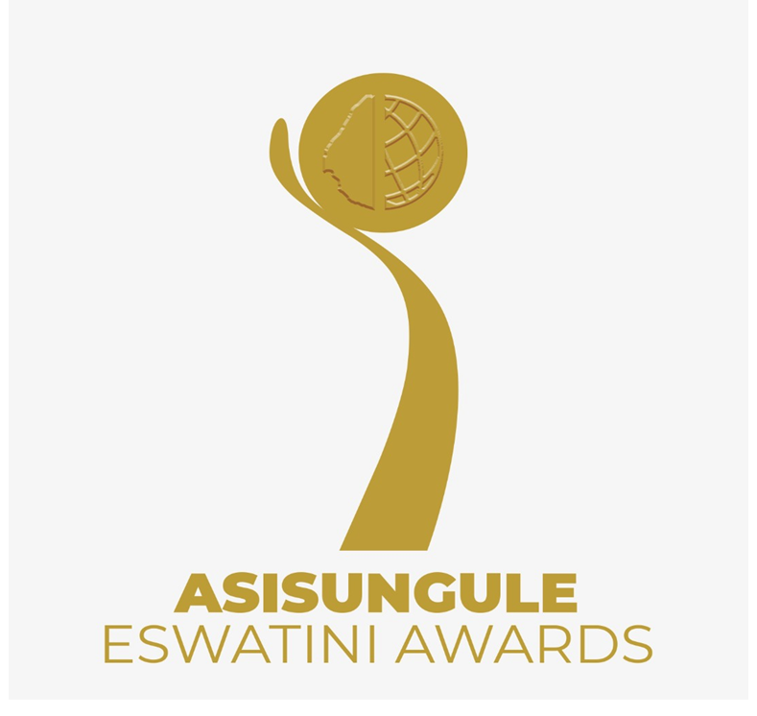
CALL FOR APPLICATIONS
Opening call: 29th June 2022
Deadline of submission: 29th August 2022

- Scope
A total number of 100 Inventors and innovators will be evaluated and selected. A total of 27 applicants will be winners from the 9 categories.
The aim is to;
- To enable the public to obtain new technological knowledge and inspire other inventors to innovate further while avoiding “reinventing the wheel”.
- To increase market exposure, networks and opportunities for nominees and winners.
- To reward inventors and innovators, especially the youth and women, for their time, effort, money and creativity.
- To increase the number and value of locally generated inventions and innovations in the local and export markets.

- Who can apply?
- An individual or team aged 7 years and above or a start-up (incorporated or not) that is either at formation, market validation n or scale-up phase
- The applicant must either have an innovation or an invention in the following sectors:
- Information and communication technology
- Engineering and Industrial designs
- Fintech
- Bio-technology and health
- Green-Climate Environment
- Food and Agriculture
- Young inventors and innovators award
- Inventors and Innovators living with disabilities
- Female Game Changer

Key
- Female Game changer: A female inventor or innovator of any age, in any category who has emerged as a disrupter.

- Young Inventors and Innovators aged 7 years to 17 years on a class of their own.

- Prizes
- Fintech Category
1st Prize – E15 000.00
2nd Prize – E10 000.00
3rd Prize – E5 000.00

- Other categories
1st Prize - E5 000.00
2nd Prize - E3 000.00
3rd Prize – Gift Hamper

- Intellectual Property Protection: Inclusive Patent Search for all applicants (Inventors) and IP registration for the top 3 winners to be determined by the kind of patent needed.

Selection Criteria
Criteria
The selection criteria will focus on a product or business model that is generating sales income or is gaining users/customers, combined any of the following:

- Inventions
An invention is a new solution to a technical problem and can be protected through patents. Patents protect the interests of inventors whose technologies are truly groundbreaking and commercially successful, by ensuring that an inventor can control the commercial use of their invention (WIPO). To qualify the applicant must prove the following:
- That the technology or Industrial design or technique is new or novel
- Description of technical information about the features and use of the invention
- Description of method for making the invention
- description of industrial applicability (technologically, scientifically, mechanically, technically) or usability which means it can be used in any kind of industry
- Description of patent or patent filing process

- Innovations
Product innovation - is a development of a new or re-designed or substantially improved good or service and taking that to the market to generate sales in a market or users. To qualify the applicant must prove the following:
- the innovation is in the market or has users or generates sales income
- Description of technical information about the features and use of the innovation
- Description of method for making the innovation
- Type of intellectual property protection method that has or will be used to protect the innovation e.g. Trademark, copyright, patent, trade secret.

- How the applicants be selected?
First Phase
The first phase will take place at RSTP where the business incubation team will select the top 5 per category (9 categories).
Second Phase
The second phase will be 60 seconds pitching videos which will be opened for ONLY the top 5 participants per category selected in phase 1.
Third Phase
In this phase three winners per category will be chosen by the selection committee.

- Application process
Download application form at www.itbi.org.sz/asisunguleeswatini/ and email the complete application form to incubation@itbi.org.sz before or on the 11th June 2022.

- Schedule – Applicants and Public (Duration 7 months 7 days)

Start

Phase1: Screening

Notify eligible applicants
(2 day)
5 - 6 Sept

Screening application +videos /pictures / link
(1 weeks)
30 Aug - 03 Sept
Advertising + Application period
(2months)
29 June - 29 Aug

Phase 2: Shortlisting

Submission of 2 minutes’ video
(Not to be published)
5 Oct
Shortlisting
(2 days)
26 – 28 Sept
Face to face pitching
(2 weeks)
12 Aug – 23 Sept

Final selection

Storytelling and Publishing
(1 week)

28 Nov – 2 Dec
Disbursement of prizes
(2 days)

22 – 23 Nov
Award ceremony + exhibition
(1 day)

18 Nov
Notify winners
(2 days)

18 Oct – 19 Oct

Screening of Videos by Selection Committee
(1 weeks)

6 Oct – 13 Oct

